*The churches of*

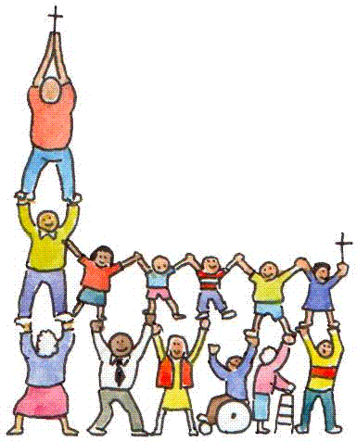**E**ast **D**ean, **F**riston and **J**evington

**E**very **D**ay **F**ollowing **J**esus

*Find us online at* **www.edfj.co.uk**

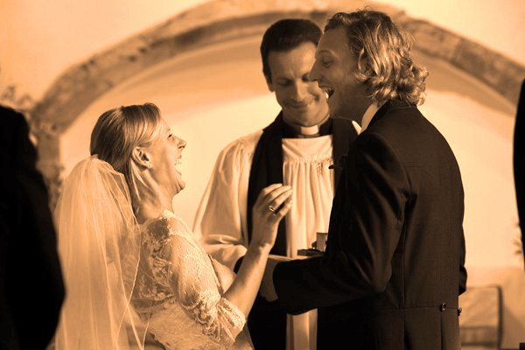 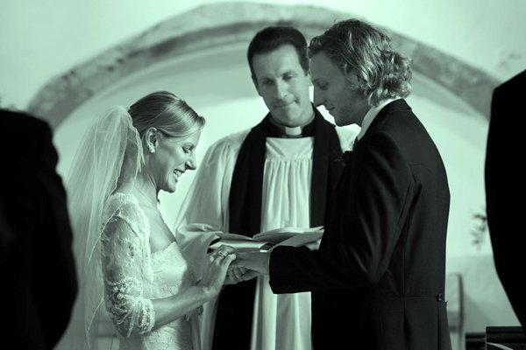 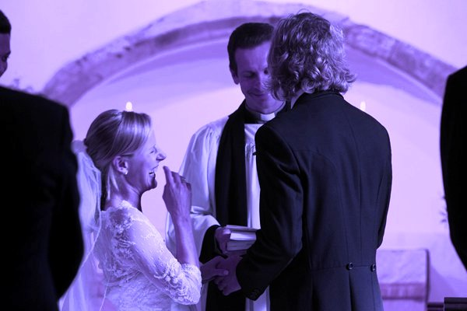

**We are delighted to hear that you would like to be married in one of our church buildings. Please be assured of our love, support, prayers and encouragement as you plan your wedding and begin your married life. Jesus Christ says**, **“I have come that you may have life in all its fullness,” (John’s gospel, in the Bible, chapter 10, verse 10). We pray that you and your partner will discover the spiritual reality of the life that he offers and that this will bring enrichment, zest, and stability to your marriage. See** [**www.christianityexplored.org**](http://www.christianityexplored.org) **for more...**

This is a form for completion by a person who wishes to marry in the parish by virtue of what is called a “qualifying connection” with the parish. Church of England ministers are under a legal duty to be satisfied that you can lawfully marry in the parish before the marriage can take place or a firm date and time can be fixed for it.

In order to make this process as quick and simple as possible, once you have established that you have a connection with the parish, you are asked to complete this form and send it toour church administrator, Mrs Becca Parke at edfjbenefice@hotmail.com **or** by post to

**Flat 20 Carew Views, 30 Carew Road, Eastbourne BN21 2JL.** To conform with the Immigration Act 2014, if you are a UK/EEA/Swiss national, you *must* also both arrange to show the Minister passports (or EEA/Swiss identity cards) for examination and copying. To arrange a time to do this please contact the Rector, David Baker, via [**davidbaker1966@gmx.co.uk**](mailto:davidbaker1966@gmx.co.uk) or via 423266. For anyone not covered in this way, more documentation is required; please contact Becca with queries about this, or anything else.

*Although it looks rather daunting at first, the form is relatively quick and easy to complete and is designed to ensure there are no loose ends later, so it is worth persevering with! Many of the details are required for legal purposes, so that the official documentation can be filled out correctly, and also to avoid any ‘sham marriages’. So please be patient and just take it step by step….!*

PLEASE BEGIN BY READING THE FOLLOWING BRIEF NOTES:

1. ***Please complete all four parts*** (That is, parts A, B, C and D. In Part D please complete sections 1 and 2, and also the question(s) in section 3 which apply directly to you.)
2. ***Before completing the form,*** and in particular part D, you may well find it helpful to read the material on the Church of England Marriage Measure 2008 on the Church of England web site at [www.cofe.anglican.org](http://www.cofe.anglican.org) including the House of Bishops’ guidance on the Measure. If you do not have access to the internet the parish will be pleased to send you a copy of an explanatory leaflet and the House of Bishops’ guidance.
3. ***If you are not certain*** about how to complete any part of the form, please contact the parish for advice.
4. ***If either of you has been married previously,*** and your former husband or wife is still alive; or ***either of you is not a UK national,*** then please alert the Minister to that as soon as possible, so that the special issues which arise can be considered without delay.
5. ***=The church minister*** is the person responsible for complying with the Data Protection Act 1998 (the data controller) in relation to the personal information you provide on and with this form. The Minister will use that information to establish whether you can lawfully be married in the parish. When the Minister has considered the completed form, it is possible that the Minister may still need to ask you for some further documents or other information, or may need to ask someone holding a official position in the parish for further information in support of your connection with the parish. If any special issue arises in your case it is also possible that the Minister may need to ask for advice on it from the diocesan legal adviser. However, if any of these becomes necessary, the Minister will see that you are kept fully informed. The Minister will share the information you have given only with those people who need to see it in order to provide the further information or advice described above.

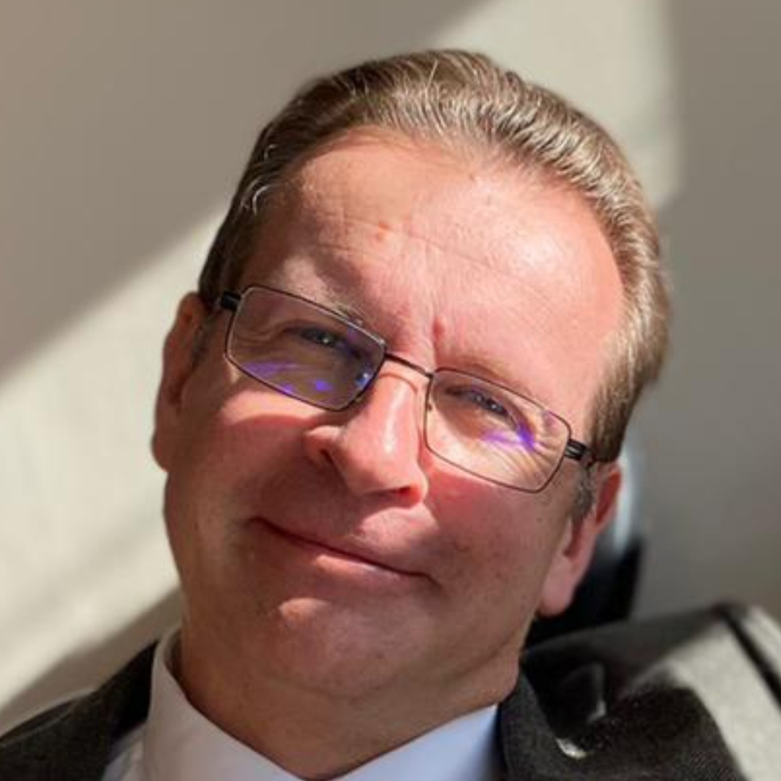The Minister of these churches is David Baker, who is Rector of the churches of East Dean, Friston and Jevington.

Contact details: The Rectory, Gilberts Drive, East Dean, nr Eastbourne, East Sussex BN20 0DL; 01323 423266 and [davidbaker1966@gmx.co.uk](mailto:davidbaker1966@gmx.co.uk)

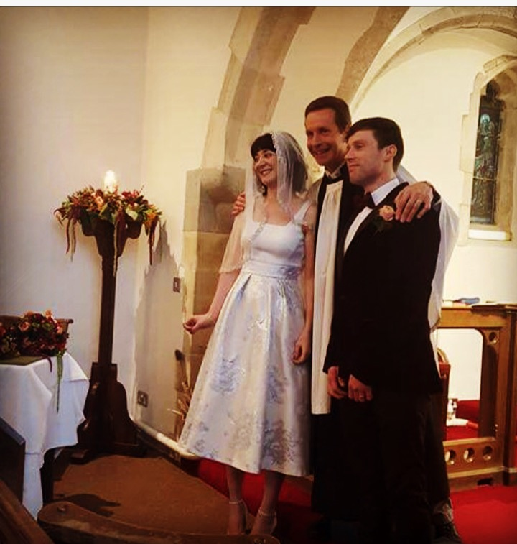

# http://fortinfamilyonline.com/Weddings/WeddingCartoon.jpgPART A – REQUEST TO MARRY IN PARISH

Person completing form– please insert full names of yourself and your fiancé(e)

I, ...................................................................................., wish to be married to ................................................................................................ according to the rites of the Church of England in the Parish of ................................................................................. by virtue of my having a qualifying connection with the parish under the Church of England Marriage Measure 2008. I confirm that the information and answers given in and supplied with this form are correct to the best of my knowledge and belief. I agree that the information may be used for the purposes described in note 5 above.

Signed ...................................................... Date .............................................

**PART B – THE PROPOSED MARRIAGE**

Some important preliminary details to note carefully:

◼ *Please note that* ***dates and times*** *of weddings depend on the availability of church buildings, so your first choice cannot automatically be guaranteed.*

◼ *Where bookings are made a long way ahead we are unfortunately not able to guarantee the* ***availability of the Rector*** *or another church minister to take the service so far in advance. Although we normally can provide someone, should none turn out to be available it does need to be understood that in such circumstances* ***you*** *would need to find a suitably-qualified church minister yourselves in order for the service to take place, and it is on that basis that bookings are taken forward.*

◼ *There will be a series of* ***Marriage Preparation Sessions*** *which all couples are encouraged and invited to attend. This could be at East Dean or it could be arranged via Zoom if you do not live in the area and would find this helpful.*

◼ ***Wedding******Rehearsals*** *normally take place early evening (eg 6.00pm) on the* ***Thursday*** *two days before a Saturday wedding. (The Rector is not available on Fridays). It is generally useful to have the couple, best man, chief bridesmaid and father of the bride present, and it may be that arrangements need to be made well in advance to secure time off work for this to happen.*

◼ *Where one of the engaged couple is a* ***foreign national****, a different procedure applies. Please speak to the Rector for more details.*

◼ ***Photography and videos:*** *couples rightly want a record of their special day. In order to facilitate this without undue disruption and intrusion, we have found the best approach is to have a “photo slot” during the service for a photographer to pose and capture whatever pictures he/she wishes. No other professional photography is permitted during the service except as the bride comes in and the couple leave. One videographer is permitted to film the service from a fixed, static position. This works best for everyone.*

⏩ My fiancé(e) and I wish to be married in the following church /place of worship (please tick as appropriate):

 St Simon and St Jude, East Dean

 St Mary’s, Friston

 St Andrew’s Jevington

Our preferred dates and times for the marriage would be (in order of preference):

(1) Date: ..................................................... Time/s: ...............................................................

(2) Date: ..................................................... Time/s: ............................................................... (3) Date: ..................................................... Time/s: ...............................................................

**PART C - GENERAL INFORMATION ABOUT YOU AND YOUR FIANCÉ(E)**

(Please complete in block capitals)

(1) BRIDE

Full name:

Present home address:

When did you move to this address?

Tel (day):

Tel (evening):

Tel (mobile):

E-mail:

Date of birth:

Your profession / occupation:

Have you been married before? Y / N

If yes, is your previous partner still alive? Y / N

If yes, how did the marriage end? (eg “divorce” / “death”)

Have you ever been in a civil partnership?

Are you a UK or foreign national?

Your parish church (for banns):

(2) BRIDEGROOM

Full name:

Present home address:

When did you move to this address?

Tel (day):

Tel (evening):

Tel (mobile):

E-mail:

Date of birth:

Your profession / occupation:

Have you been married before? Y / N

If yes, is your previous partner still alive? Y / N

If yes, how did the marriage end? (eg “divorce” / “death”)

Have you ever been in a civil partnership?

Are you a UK or foreign national?

Your parish church (for banns):

**◼ Note 1:** Where a previous marriage has ended in divorce and a previous partner is still alive, a Service of Blessing in church can be offered after re-marriage in a civil wedding ceremony.

**◼ Note 2:** The law also forbids a person who has entered into a civil partnership to enter into a marriage while the civil partnership is still subsisting.

**◼ Note 3:** The Church of England does not offer weddings for two people of the same gender.

(3) **Are you related, or are you connected by marriage? If so, how?**

**(4) Keeping in touch: what will be your address after your marriage?**

For the purposes of data protection law, the data controller is the Minister of the parish, Revd David Baker, and the PCC who will use the information on this form to ensure that the legal requirements relating to the marriage are compiled with and to make arrangements for the wedding ceremony. The Minister and PCC will only share the information with those who need to see it for those purposes. Your data may be stored on behalf of the Minister, or the PCC either on systems owned by the Archbishops’ Council of the Church of England or other software.

**After your wedding, your church would love to keep in touch with you on anniversaries and to let you know about services and events that may interest you.**

**If you are happy for the church to keep in touch with you in this way, please tick this box:** q

**(5) Parents of the bride and groom**

In the space below, please list details about your mother / father / parents for the official Marriage Document (the legal document which in 2021 replaced the old marriage register as a result of government changes).

The 2021 changes make it possible to record more of your family members than before on the official marriage documentation. You can now ***each***list up to ***four*** people, which include: mother, father, parent and step-parent.

So, for example, if you have a birth mother who is different from your mother who adopted you, it is possible to list both, *should you wish to.* Or if one parent passed away, and the remaining parent remarried, it is possible to list both.

For each one, please state below on this page the following four things:

* 1 Their full name
* 2 The relationship (eg “groom’s father” or “bride’s mother”)
* 3 Their occupation / profession
* 4 Whether they are alive or deceased

# PART D – YOUR QUALIFYING CONNECTION WITH THE PARISH

**Please complete sections 1 and 2 and whichever questions(s) in section 3 apply**

**PART D** - *SECTION 1* Please tick one or more relevant statement(s)

**I wish to rely on a connection with the parish by virtue of** one or more **of the following:**

 (a) I was baptised in the parish (by a Church of England service/form of baptism)

 (b) I have been confirmed (by a Church of England service) and my confirmation is entered in a register belonging to a church or chapel in the parish

 (c) My parent or grandparent was married in the parish by a Church of England service

 (d) I have had my usual place of residence in the parish for at least 6 months*

 (e) My parent has had his or her usual place of residence in the parish for at least 6 months during my lifetime*

  (f) I have habitually attended public worship at Church of England services in the parish for at least 6 months **

 (g) At least one of my parents has habitually attended public worship at Church of England services in the parish for at least 6 months during my lifetime**

# PART D - *SECTION 2*

Does any of the information on which you might be relying to show your connection with the parish:

***Either:***Give a name for you which is different from the one you have used on this form?

***Or:***Give a surname for any parent or grandparent of yours which is different from your surname as set out on this form?

 Yes

 No

**If yes,** please:

• give the previous/other name(s)

• explain how the difference has arisen and

• if the reason for the difference between the names is that you have changed your name, explain when and how the change(s) took place and provide any documentary information (e.g. adoption certificate, marriage certificate, deed poll for change of name)

# *PLEASE NOW GO ON TO COMPLETE THE PART(S) OF SECTION 3, ON THE NEXT PAGE, WHICH CORRESPOND TO THE STATEMENT(S) YOU HAVE TICKED IN SECTION 1 ABOVE*

# PART D - *SECTION 3*

In this section you **only** need to answer the questions which relate to the connection(s) you have ticked in section 1. Please give exact dates, places, names etc if possible – if not, please give as much information as you can. The documents you supply will be returned to you. If necessary, please complete your answer on a separate piece of paper and submit it with the form.

## (a) My Connection is that I was baptised in the parish (by a Church of England service/form of baptism)

When were you baptised?

Where were you baptised?

What documentary or other information do you have for this? (Please submit any copy of an entry in the baptism register, baptism certificate or other documents with this form)

## (b) My connection is that I have been confirmed (by a Church of England service) and my confirmation is entered in a register belonging to a church or chapel in the parish.

When were you confirmed?

Where were you confirmed?

Who prepared you for confirmation?

In which register is your confirmation recorded?

What documentary or other information do you have as regards the registration of your confirmation? (Please submit any copy of an entry in the confirmation register, certificate etc or other documents with this form)

## (c) My connection is that my parent or grandparent was married in the parish by a Church of England service.

## When and where did the marriage take place?

Please give names of the parties to the marriage, and state how the relevant party/parties are related to you.

What documentary or other information do you have for this? (Please submit a copy of the relevant entry in the marriage register, marriage certificate or other documents with this form)

**(d) My connection is that I have had my usual place of residence in the parish for at least 6 months.** This can apply whether or not you are still resident in the parish.

## Please give each address at which you have been resident in the parish:

## The dates between which that address was/has been your usual place of residence:

What documentary or other information do you have for the above? (Please submit the documents with this form)

## (e) My connection is that my parent has had his or her usual place of residence in the parish for at least 6 months during my lifetime. This can apply whether or not your parent(s) is/are still resident in the parish.

Please give each address at which a parent of yours has been resident in the parish:

The name/s of the parent/s who reside there:

The dates between which that address is/was his/her/their usual place of residence:

What documentary or other information do you have for the above? (Please submit the documents with this form)

## (f) My connection is that I have habitually attended public worship at Church of England services in the parish for at least 6 months. This can apply whether or not you are still attending worship in the parish.

When did you begin to attend public worship habitually in the parish?

If you no longer do so, when did you cease to do so?

Please state:

Where you worshipped in the parish during this period:

How often/on what occasions:

What types of services you attended:

What documentary or other information do you have for the above? (E.g. a letter from a previous Rector or current church member to confirm you have worshipped here if you no longer do so. Please submit any such documents with this form.)

## (g) My connection is that my parent has habitually attended public worship at Church of England services in the parish for at least 6 months during my lifetime. This can apply whether or not your parent(s) is/are are still attending worship in the parish.

When did your parent(s) begin to attend public worship habitually in the parish?

If that is no longer the case, when did it cease?

Please give his/her/their name(s) and his/her/their address(es) over that period:

Please state:

Where he/she/they worshipped in the parish during that period:

How often/on what occasions:

At what types of services:

What documentary or other information do you have for the above? (Please submit the documents with this form)

**End of form; Thank you!**