*The churches of*

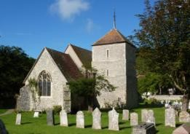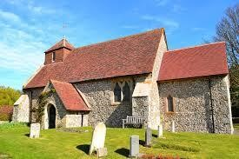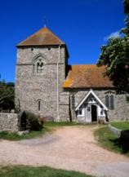

**E**ast **D**ean, **F**riston and **J**evington

**E**very **D**ay **F**ollowing **J**esus

Rector: Revd David Baker, The Rectory, Gilberts Drive, East Dean, near Eastbourne, East Sussex BN20 0DL

Telephone: 01323 423266 Admin E-mail: edfjbenefice@hotmail.com **www.edfj.co.uk**

# APPLICATION FOR THE INTERMENT OF ASHES

## (a) Basic details

Full name of deceased, and their address at time of death:

Date of birth:

Date of death:

Name and address of next of kin:

Telephone / e-mail:

Requested place of interment:

Basic cost of interment: £198 Interment Fee, £30 Verger’s Fee (see section C over the page)

**PLEASE NOTE**

* In accordance with the Chancellor's Directions, if the ashes are to be interred in the Garden of Remembrance, the ashes will be placed directly in the ground. Wooden containers are only permitted in an existing family grave.
* You will need to provide a certificate of authentication for the ashes, which is usually given to you at the Crematorium. If you do not have one and cannot obtain one from the Crematorium, please let us know.

## (b) Memorial plaque

The P.C.C.s have approved the following type of memorial plaque to be placed on the boards in the memorial gardens of all three Churches:

A brass plaque where the inscription is first engraved and then sent away for the engraved inscription to be filled with white enamel, which is then baked to give a long lasting very durable form of inscription on a virtually non-corrodible plaque. The cost of provision of a plaque and its placement on the memorial board is **£75**. Please note, **no** other plaques are permitted in the Garden of Remembrance.

**ALL PLAQUES MUST MEASURE 3.5"** **X 1"**

**Location of plaque requested:** East Dean / Friston / Jevington (delete as appropriate)

**Inscription on the plaque:** please write the name of the deceased, their date of birth and date of death below. (Unfortunately there is no space for extra wording in addition to those details because of the constraints imposed by the size of the plaque itself.)

**At Jevington only,** it is possible as an alternative to have an entry in the Book of Remembrance (name, date of birth and date of death only) for **£30** instead of having a plaque**.** Please indicate here if you wish to have this arranged: Yes / No (delete as appropriate)

Name:

Date of birth: Date of death:

***(c) Summary of charges:***

* Basic Church of England interment fee (£198)
* Verger’s fee (£30)
* Plaque & Placement (£75) *or for two names with dates, £85*
* Book of Remembrance (£30) *(Jevington only)*

**Total cost = *Either* £303 (Plaque – East Dean, Friston and Jevington) *or* = £258 (Book of Remembrance instead of plaque – Jevington only)**

Please tick which church you would like the interment to be held at:

**EAST DEAN FRISTON JEVINGTON**

For **East Dean and Friston,** please email this form to Becca Parke at [edfjbenefice@hotmail.com](mailto:edfjbenefice@hotmail.com), and make the appropriate payment via BACS online to:

The Parochial Church Council of East Dean and Friston, Sort Code: 20-27-91; Account Number: 30715085 OR post a copy of this form together with a cheque payable to **The Parochial Church Council of East Dean and Friston** to:- Peter Hewitt, 9a Sth Cliff Tower, Bolsover Rd, Eastbourne BN20 7JN

For **Jevington**, please email the form to Jenny Wootton at [jenny@jawootton.co.uk](mailto:jenny@jawootton.co.uk), and make the appropriate payment via BACS online to:

Jevington Parochial Church Council, Sort Code 40-37-35 Account No: 30480428 OR post a copy of this form together with a cheque payable to **Jevington PCC** to:- Jenny Wootton, 3 The Crescent, Willingdon, Eastbourne BN20 9RN