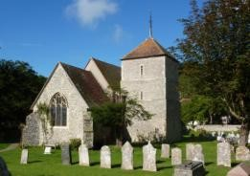
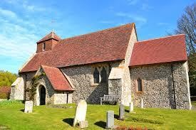
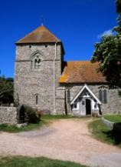
The churches of
East Dean, Friston and Jevington
Every Day Following Jesus

Rector: Revd David Baker, The Rectory, Gilberts Drive, East Dean, near Eastbourne, East Sussex BN20 0DL
Telephone: 01323 423266 Admin E-mail: edfjbenefice@hotmail.com www.edfj.co.uk

APPLICATION FOR THE INTERMENT OF ASHES

(a) Basic details

Full name of deceased, and their address at time of death:

Date of birth:
Date of death:
Name and address of next of kin:

Telephone / e-mail:
Requested place of interment:

Basic cost of interment: £182 Interment Fee, £30 Verger’s Fee (see section C over the page)

PLEASE NOTE that in accordance with the Chancellor's Directions, if the ashes are to be interred in the Garden of Remembrance, the container must be cardboard/fully biodegradable, otherwise the ashes are placed loose, directly in the ground. Wooden containers are only permitted in an existing family grave.

Memorial plaque: see over

(b) Memorial plaque
The P.C.C.s have approved the following type of memorial plaque to be placed on the boards in the memorial gardens of all three Churches:
A brass plaque where the inscription is first engraved and then sent away for the engraved inscription to be filled with white enamel, which is then baked to give a long lasting very durable form of inscription on a virtually non-corrodible plaque.
ALL PLAQUES MUST MEASURE 3.5" X 1"
The cost of provision of a plaque and its placement on the memorial board is £95
Location of plaque requested: East Dean / Friston / Jevington (delete as appropriate)
Inscription on the plaque: please write the name of the deceased, their date of birth and date of death below. (Unfortunately there is no space for extra wording in addition to those details because of the constraints imposed by the size of the plaque itself.)
At Jevington only, it is possible as an alternative to have an entry in the Book of Remembrance (name, date of birth and date of death only) for £25 instead of having a plaque. Please indicate here if you wish to have this arranged: Yes / No (delete as appropriate)
Name:
Date of birth: Date of death:
(c) Summary of charges:

- Basic Church of England interment fee (£182)
- Verger’s fee (£30)
- Plaque (£95)
- Book of Remembrance (£25) (Jevington only)

Total cost = Either £297 (Plaque – East Dean, Friston and Jevington) or = £237 (Book of Remembrance instead of plaque – Jevington only)

Please tick which church you would like the interment to be held at:

EAST DEAN FRISTON JEVINGTON

For East Dean and Friston, please email this form to Becca Parke at edfjbenefice@hotmail.com, and make the appropriate payment via BACS online to:
The PCC of East Dean and Friston, Sort Code: 20-27-91; Account Number: 30715085 OR post a copy of this form together with a cheque payable to East Dean and Friston PCC to:- Peter Hewitt, 9a Sth Cliff Tower, Bolsover Rd, Eastbourne BN20 7JN

For Jevington, if paying online (our preferred option) please email the form to Jenny Wootton at jenny@jawootton.co.uk, and make the appropriate payment by credit transfer to:
Jevington Parochial Church Council, Sort Code 40-37-35 Account No: 30480428 OR post a copy of this form together with a cheque payable to Jevington PCC to:- Jenny Wootton, 3 The Crescent, Willingdon, Eastbourne BN20 9RN

